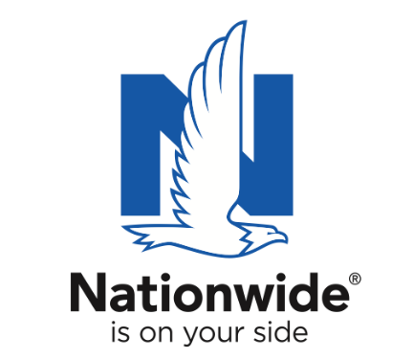
FOR IMMEDIATE RELEASE

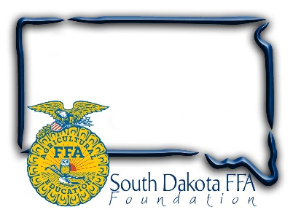
October 3, 2023

Contact:
Gerri Eide
SD FFA Foundation
gerri@sdffafoundation.org
605-765-4865

Nominate Local Teachers for SD’s Top
Agricultural Educator Award

Nationwide’s Golden Owl Award® recognizes extraordinary agricultural teachers in nine states and supplies funding to advance their programs

Bath, SD – Agriculture educators play a vital role within their communities by investing countless hours to prepare and empower students for successful careers in the industry. To honor their contributions and support them with additional resources, Nationwide and the SD FFA Foundation are accepting nominations for South Dakota’s leading agricultural teachers for a chance to be named as the 2023-2024 Ag Educator of the Year.

Nationwide and its state partners recently recognized 64 exceptional agricultural teachers as 2022-2023 Golden Owl Award® finalists and then honored nine grand prize winners as their state’s Ag Educator of the Year. Every finalist received $500 in funding to help advance their programs and the grand prize winners received an additional $3,000 to boost their efforts and the coveted Golden Owl Award trophy.

Nominate any South Dakota agriculture educator for the 2023-2024 Golden Owl Award October 3rd through Dec 31 at https://bit.ly/SDGoldenOwl or scanning the code.

“The Golden Owl Award seeks to thank agricultural teachers for the extraordinary care they bring to their work as they go above and beyond in educating America’s youth and future leaders,” said Brad Liggett, Nationwide’s president of Agribusiness. “We encourage students, parents, fellow teachers and others to nominate their favorite agricultural teachers to acknowledge their hard work.”

Following the nomination period, closing December 31, a selection committee will evaluate nominations and select 8 finalists in SD who will receive an individualized plaque and $500. One finalist will then be chosen as the grand prize winner, earning the 2023-2024 Ag Educator of the Year title for SD and receiving the coveted Golden Owl Award trophy and $3,000 to help fund future educational efforts.
Nationwide supports the future of the ag community through meaningful sponsorships of national and local organizations. In conjunction with the Golden Owl Award, Nationwide is donating $5,000 to each participating state’s FFA, including SD, to further support the personal and professional growth of students, teachers and advisors alike.

To nominate a teacher or learn more about the Golden Owl Award, visit GoldenOwlAward.com.

About Nationwide
Nationwide, a Fortune 100 company based in Columbus, Ohio, is one of the largest and strongest diversified insurance and financial services organizations in the United States. Nationwide is rated A+ by both A.M. Best and Standard & Poor’s. An industry leader in driving customer-focused innovation, Nationwide provides a full range of insurance and financial services products including auto, business, homeowners, farm and life insurance; public and private sector retirement plans, annuities, mutual funds and ETFs; excess & surplus, specialty and surety; pet, motorcycle and boat insurance. For more information, visit www.nationwide.com. Follow us on Facebook and Twitter.

Nationwide, Nationwide is on your side and the Nationwide N and Eagle are service marks of Nationwide Mutual Insurance Company. © 2023

